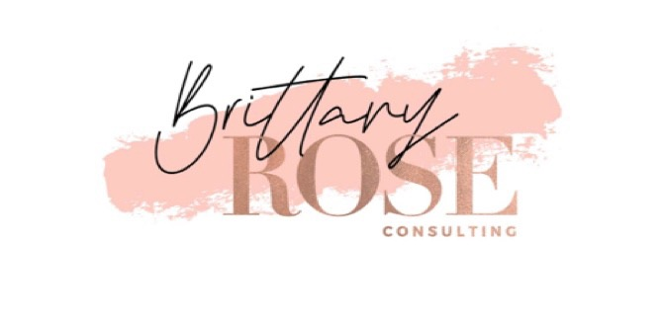
Free Financial Counseling and Affordable Housing Application Assistance

The Bronx
We Stay/Nos Quedamos
754 Melrose Avenue
Bronx, NY 10451

Brooklyn
Los Sures – Southside United HDFC
145 South 3rd Street
Brooklyn NY 11211

Manhattan
East Harlem Council for Community Improvement (EHCCI)/Hellgate Management Corporation
413 East 120th Street, Room 305
New York, NY 10035

Queens

Legal Hand Jamaica

149-13 Jamaica Avenue
Jamaica, NY 11432

Call 311 to schedule a free financial counseling appointment at one of these locations.

